УО «Белорусский государственный университет информатики и радиоэлектроники»

Кафедра ПОИТ

Отчет по лабораторной работе №2.1

по предмету «Основы алгоритмизации и программирования»

Вариант 18

Выполнил:

Егоров А.С.

Гр. 351005

Проверил:

Данилова Г. В.

Минск 2023

**Задание:**

n треугольников заданы длинами своих сторон. Найти треугольник максимальной площади.

**Код программы Delphi:**

Program Exercise1;

Uses

System.SysUtils;

Var

I, N: Integer;

A, B, C, CurrentSquare, HighestSquare: Real;

P: Real; // half-perimeter

IsCorrect: Boolean;

Begin

// initialization

A := 0.0;

B := 0.0;

C := 0.0;

CurrentSquare := -1.0;

HighestSquare := 1.0;

P := 0.0;

IsCorrect := False;

Writeln('The program finding a triangle with the highest square.'#13#10);

// make sure that user enter correct size

Repeat

Try

Writeln('Enter how many triangles: ');

Readln(N);

If N < 1 Then

Writeln('Entering number cannot be less than 1!!! Try again.')

Else

IsCorrect := True;

Except

Writeln('Invalid numeric type!!! Try again.');

End;

Until IsCorrect;

// input sides of triangles

For I := 1 To N Do

Begin

Repeat

// inputting first side

IsCorrect := False;

Repeat

Try

Writeln('Enter first side of triangle number ', I, ': ');

Readln(A);

If (A < 0.0) Or (A = 0.0) Then

Writeln('Side cannot be less than 0!!! Try again.')

Else

IsCorrect := True;

Except

Writeln('Invalid numeric type!!! Try again.');

End;

Until IsCorrect;

// inputting second side

IsCorrect := False;

Repeat

Try

Writeln('Enter second side of triangle number ', I, ': ');

Readln(B);

If (B < 0.0) Or (B = 0.0) Then

Writeln('Side cannot be less than 0!!! Try again.')

Else

IsCorrect := True;

Except

Writeln('Invalid numeric type!!! Try again.');

End;

Until IsCorrect;

// inputting third side

IsCorrect := False;

Repeat

Try

Writeln('Enter third side of triangle number ', I, ': ');

Readln(C);

If (C < 0.0) Or (C = 0.0) Then

Writeln('Side cannot be less than 0!!! Try again.')

Else

IsCorrect := True;

Except

Writeln('Invalid numeric type!!! Try again.');

End;

Until IsCorrect;

// check the triangle for correctness

If (A + B > C) And (A + C > B) And (B + C > A) Then

IsCorrect := True

Else

Begin

Writeln('Triangle with sides ', A:5:3, ' ', B:5:3, ' ', C:5:3,

' does'#39, 't exist.');

IsCorrect := False;

End;

Until IsCorrect;

// making counts

P := (A + B + C) / 2.0;

CurrentSquare := Sqrt(P * (P - A) * (P - B) * (P - C));

If CurrentSquare > HighestSquare Then

HighestSquare := CurrentSquare;

End;

// ouput

Writeln('The best triangle has square equal ', HighestSquare:5:3);

// freeze console

Writeln('Press enter to exit...');

Readln;

End.

**Код программы С++:**

#include<iostream>

int main()

{

//initialization

int n = 0;

double a = 0.0, b = 0.0, c = 0.0, highestSquare = -1.0, currentSquare = -1.0,

p = 0.0; // half-perimeter

bool isIncorrect = true;

std::cout << "The program finding a triangle with the highest square.\n\n";

// make sure that user enter correct size

do

{

std::cout << "Enter how many triangles: ";

std::cin >> n;

if (std::cin.get() != '\n')

{

std::cin.clear();

std::cin.ignore(4124,'\n');

std::cerr << "Invalid type!!! Try again.\n";

}

else if (n < 1)

std::cerr << "Entering number cannot be less than 1!!! Try again.\n";

else

isIncorrect = false;

} while (isIncorrect);

// input sides of triangles

for (int i = 0; i < n; i++)

{

do

{

//inputting first side

isIncorrect = true;

do

{

std::cout << "Enter first side of triangle number " << i + 1 << ": ";

std::cin >> a;

if (std::cin.get() != '\n')

{

std::cin.clear();

std::cin.ignore(4211,'\n');

std::cerr << "Invalid type!!! Try again.\n";

}

else if (a < 0.0 || a == 0.0)

std::cerr << "Side cannot be less than 0!!! Try again.\n";

else

isIncorrect = false;

} while (isIncorrect);

//inputting second side

isIncorrect = true;

do

{

std::cout << "Enter second side of triangle number " << i + 1 << ": ";

std::cin >> b;

if (std::cin.get() != '\n')

{

std::cin.clear();

std::cin.ignore(4211,'\n');

std::cerr << "Invalid type!!! Try again.\n";

}

else if (b < 0.0 || b == 0.0)

std::cerr << "Side cannot be less than 0!!! Try again.\n";

else

isIncorrect = false;

} while (isIncorrect);

//inputting third side

isIncorrect = true;

do

{

std::cout << "Enterse third side of triangle number " << i + 1

<< ": ";

std::cin >> c;

if (std::cin.get() != '\n')

{

std::cin.clear();

std::cin.ignore(4512,'\n');

std::cerr << "Invalid type!!! Try again.\n";

}

else if (c < 0.0 || c == 0.0)

std::cerr << "Side cannot be less than 0!!! Try again.\n";

else

isIncorrect = false;

} while (isIncorrect);

// check the triangle for correctness

if (a + b > c && a + c > b && b + c > a)

isIncorrect = false;

else

{

std::cerr << "Triangle with sides " << a << " " << b << " " << c

<< " doesn't exist.\n";

isIncorrect = true;

}

} while (isIncorrect);

// making counts

p = (a + b + c) / 2.0;

currentSquare = sqrt(p * (p - a) * (p - b) * (p - c));

(currentSquare > highestSquare) ? highestSquare = currentSquare

:highestSquare;

}

// output

std::cout << "The best triangle has square qeual " << highestSquare << std::endl;

return 0;

}

**Код программы Java:**

import java.util.Scanner;  
  
// Press Shift twice to open the Search Everywhere dialog and type `show whitespaces`,  
// then press Enter. You can now see whitespace characters in your code.  
public class Main {  
 public static void main(String[] args) {  
 //initialization  
 final int SIDE = 3;  
 int n = 0;  
 double a = 0.0;

double b = 0.0;

double c = 0.0;

double highestSquare = -1.0;

double currentSquare = -1.0

double p = 0.0; // half-perimeter  
 boolean isIncorrect = true;  
 Scanner in = new Scanner(System.in);  
 System.out.println("The program finding a triangle with the highest square.");  
 // make sure that user enter correct size  
 do  
 {  
 try {  
 System.out.println("Enter how many triangles: ");  
 n = Integer.parseInt(in.nextLine());  
 if (n < 1)  
 System.err.println("Entering number cannot be less than 1!!! Try

again.");  
 else  
 isIncorrect = false;  
 }  
 catch (NumberFormatException ex)  
 {  
 System.err.println( "Invalid type!!! Try again.");  
 }  
 } while (isIncorrect);  
 // input sides of triangles  
 for (int i = 0; i < n; i++)  
 {  
 do {  
 //inputting first side  
 isIncorrect = true;  
 do {  
 try {  
 System.out.println("Enter first side of triangle number "

+ (i + 1) + ": ");  
 a = Double.parseDouble(in.nextLine());  
 if (a < 0.0 || a == 0.0)  
 System.err.println("Entering number cannot be less than

0!!! Try again.");  
 else  
 isIncorrect = false;  
 }  
 catch (NumberFormatException ex)  
 {  
 System.err.println( "Invalid type!!! Try again.");  
 }  
 }while (isIncorrect);  
 //inputting second side  
 isIncorrect = true;  
 do {  
 try {  
 System.out.println("Enter second side of triangle number "

+ (i + 1) + ": ");  
 b = Double.parseDouble(in.nextLine());  
 if (b < 0.0 || b == 0.0)  
 System.err.println("Entering number cannot be less than

0!!! Try again.");  
 else  
 isIncorrect = false;  
 }  
 catch (NumberFormatException ex)  
 {  
 System.err.println( "Invalid type!!! Try again.");  
 }  
 }while (isIncorrect);  
 //inputting third side  
 isIncorrect = true;  
 do {  
 try {  
 System.out.println("Enter third side of triangle number "

+ (i + 1) + ": ");  
 c = Double.parseDouble(in.nextLine());  
 if (c < 0.0 || c == 0.0)  
 System.err.println("Entering number cannot be less than

0!!! Try again.");  
 else  
 isIncorrect = false;  
 }  
 catch (NumberFormatException ex)  
 {  
 System.err.println( "Invalid type!!! Try again.");  
 }  
 }while (isIncorrect);  
 // check the triangle for correctness  
 if (a + b > c && a + c > b && b + c > a)  
 isIncorrect = false;  
 else  
 {  
 System.err.printf( "Triangle with sides %.3f %.3f %.3f doesn't

exist\n",a,b,c);  
 isIncorrect = true;  
 }  
 }while (isIncorrect);  
 p = (a + b + c) / 2.0;  
 currentSquare = Math.sqrt(p * (p - a) * (p - b) * (p - c));  
 if (currentSquare > highestSquare)  
 {  
 highestSquare = currentSquare;  
 }  
 }  
 System.out.printf("The best triangle has square equal %.3f.\n",highestSquare);  
 }  
}

**Скриншоты:**

**C++:**

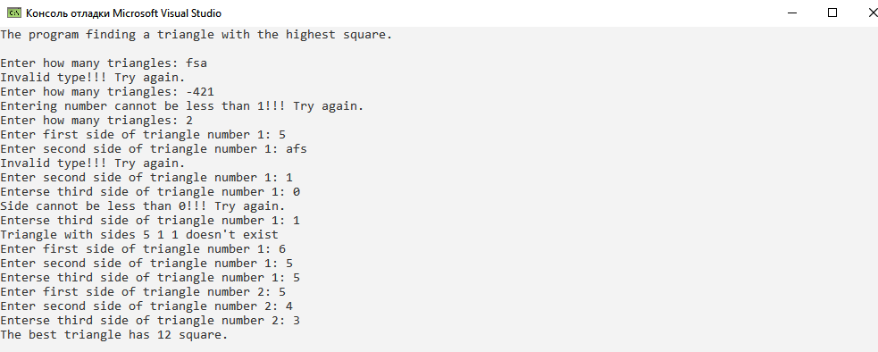

**Delphi:**

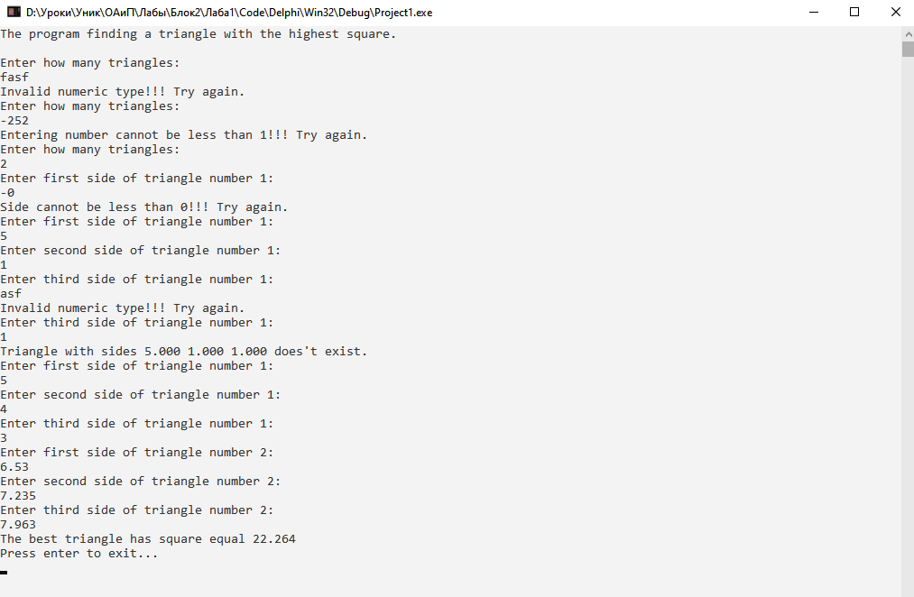

**Java:**

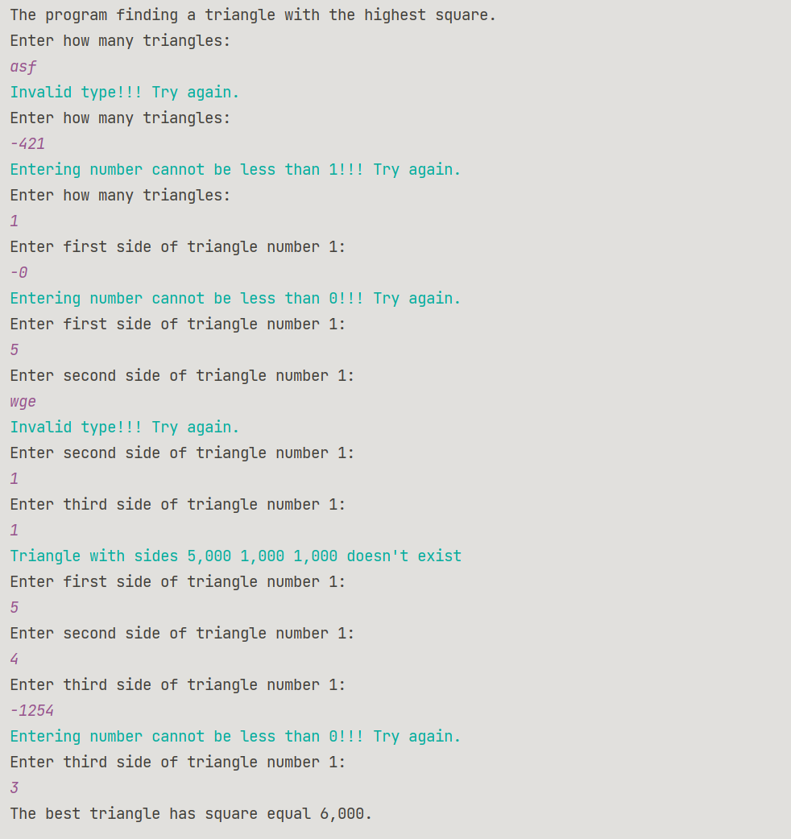

**Блок-схема:**



